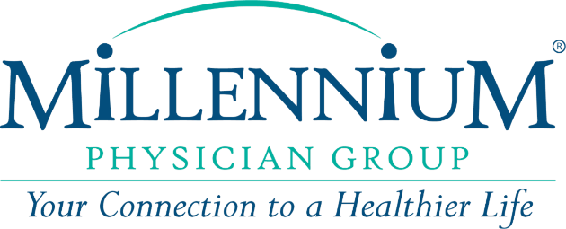
JOB DESCRIPTION: HEALTHCARE RECRUITER
Millennium Physician Group is seeking to hire a full-time Healthcare Recruiter who will be responsible for the organization’s talent management efforts including full lifecycle recruiting within a dynamic, growing, and changing environment. They will be a key member of the Human Resources team, partnering closely with others the Talent Acquisition team and collaborating with hiring managers across multiple locations to develop hiring strategies that will enable us to fill critical roles and identify key hiring sources.
ABOUT MILLENNIUM PHYSICIAN GROUP:
Millennium Physician Group is one of the largest comprehensive independent physician groups with healthcare providers located throughout Florida and in the surrounding states of North Carolina and Texas. Our physicians are continuously recognized for their dedication and commitment to improving the health of their patients and residents in their communities. At Millennium Physician Group, our employees are the foundation of our success. Our promise is to provide you with the tools to do your job successfully, as well as providing a team atmosphere that empowers you to seek better ways to deliver care to our patients and their families. We also promise to care for you as an individual and help you grow in your role.

JOB STANDARDS:
- Lead the recruiting process through the entire candidate life cycle
- Partner with hiring managers to define talent requirements and develop sourcing strategies to execute on business needs
- Build and maintain external networks by proactively searching for active and passive candidates through community involvement, diversity, social media, military/veterans, key schools and universities, etc.
- Maintain current knowledge of Equal Employment Opportunity (EEO) and affirmative action guidelines and laws, such as the Americans with Disabilities Act.
- Utilize systems and processes, develop recruiting metrics to be measured and communicated regularly to the executive team, including time to fill and retention of new hires
- Assist in development of the university relations program, including attendance at college job fairs, advisory boards, etc.
- Utilize recruiting reports and recruitment metrics to build better strategies
- Act as a point of contact and build influential candidate relationships during the selection process
- Experienced in developing recruitment strategy
- Provide coaching and guidance to junior level coaching staff and hiring managers involved in the interview process
- Understand market competition and conditions and adjust search methodology and candidate recommendations accordingly
- Perform other duties as assigned by the Talent Acquisition Manager
RECRUITER QUALIFICATIONS:
- Bachelor’s Degree required, preferably in Human Resources Management, Business Administration
- Five (5) years of recruiting experience, preferably in the healthcare field; experience recruiting corporate positions (i.e., human resources, accounting, finance, etc.) preferred
- HRCI and/or SHRM Certification preferred.
- Must have strong time management skills and the ability to multitask and maintain focus and discipline
- Must have excellent written and oral communication skills
- Highly proficient in Microsoft Office, the Internet and computer aptitude
- Desire to grow professionally with networking and ongoing training opportunities
- Ability to travel when required, including to our Fort Myers, FL headquarters regularly if outside the region.
- Supports workplace diversity, equity and inclusion

This position earns competitive compensation plus a full benefits package! We also offer a 401k plan, 3 weeks of paid time off which increases incrementally, opportunities for growth, and a great environment to learn, grow, and develop your skills.
WORK SCHEDULE:
Though the typical schedule for this position is Monday through Friday from 8 am to 5 pm, we are committed to a degree of flexibility regarding working hours.

ARE YOU READY TO JOIN OUR MILLENNIUM TEAM?
Do you have a passion for finding the right candidates for the right positions? Do you have excellent interpersonal skills and a positive attitude? Are you organized and detail-oriented? Do you have exceptional phone and networking skills? If so, then you might just be perfect candidate for this healthcare recruiter role.

